Fiche concours

« Astérix et Obélix arrivent à Barium »

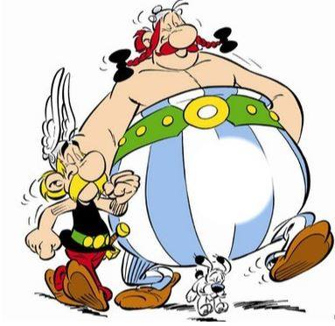

Nome: _________________________________________________________________________

Cognome: ______________________________________________________________________

Classe: _________________________________________________________________________

Scuola: ________________________________________________________________________

E-mail: ________________________________________________________________________

Numero di telefono: ______________________________________________________________

Le iscrizioni sono aperte dal 12 novembre al 14 dicembre

